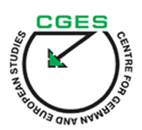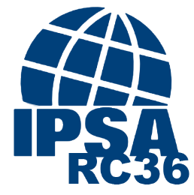

CALL FOR PAPERS

PAPERS DEVELOPMENT WORKSHOP
EMPIRICAL ANALYSIS OF POLITICAL POWER
May 24, 2019 | Saint Petersburg, Russia

Deadline for Abstracts: February 15, 2019 (abstracts up to 250 words, at ipsa.rc36@gmail.com)
Decision on Abstracts: February 21, 2019

Please consider submitting your paper to the workshop “Empirical Analysis of Political Power” organized by the Research Committee on Political Power (IPSA RC36) and the Centre for German and European Studies (CGES) of Saint Petersburg State University.

For many years IPSA RC36 has been supporting the development of political power theories and new methods allowing to test them empirically. Considering the recent popularity of network analysis, IPSA RC36 is holding its next papers development workshop in cooperation with the CGES, the center famous for its special focus on this methodology.

We invite scholars interested in discussing new approaches to the empirical analysis of political power to join us at the CGES in Saint Petersburg on May 24, 2019.

We are providing our workshop participants with an opportunity to meet experts on political power from the IPSA RC36 and specialists on networking methods from the CGES. Thus, we aim not only at exploring problems of empirical power analysis and its solutions, but what is more important, to provide feedback and support to scholars already working on such papers.

As this workshop we will also talk about the potential and challenges of network analysis in political power studies, we welcome papers on distinct forms of power in networks, which include, but are not restricted to, power-as-control and power-as-access, networking power, network power, networked power, and network-making power.

We are interested in contributions that share our commitment to the rigorous conceptual analysis of power, methodological issues, linking theory to practice, and proposing systematic testing of theoretical models with known empirical evidence and new data.

Workshop Leaders
Giulio Gallarotti (Wesleyan University, current IPSA RC36 Chair)
Mark Haugaard (National University of Ireland, Journal of Political Power Editor)
Philip G. Cerny (University of Manchester and Rutgers-Newark)
Alina V. Vladimirova (Institute of Oriental Studies of the RAS, current IPSA RC36 Vice-Chair)
Artem Antonyuk (Centre for German and European Studies)

Venue:
Centre for German and European Studies (CGES) of Saint Petersburg State University
Address: Universitetskaya 7/9, St. Petersburg, Russia

Visa Support:
Registered authors coming from abroad will receive visa support from the workshop organizers.

For more details, please contact Alina V. Vladimirova (alina.v.vladimirova@gmail.com) and Artem Antonyuk (artem.antonyuk@protonmail.com).

Looking forward to your paper proposals!

Alina Vladimirova
Artem Antonyuk
Giulio Gallarotti

